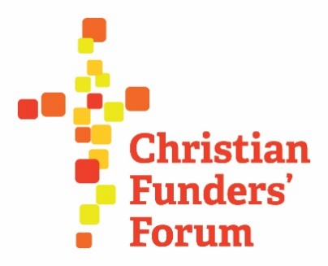
Christian Funders Forum Meeting
Tuesday 6th October 2020; 11.00am
Virtual meeting

Attendance – Melanie Churchyard (Childs Trust), Greg Davies (Smith Bradbeer Charitable Trust), Sian Edwards (Andrews Charitable Trust), Paul Garratt (The Cinnamon Network), John Higgs (The Joseph Rank Trust), Danielle Howes (Bishop Radford Trust), Daniel Jones (Stewardship), Brian Ladd (The London Institute for Contemporary Christianity), Vikki McLachlan (The Jerusalem Trust – CFF Chair), Christine Muskett (The Henry Smith Charity), Roger Northcott (Hinchley Trust), Jeremy Noles (All Churches Trust), Safiya Nyirongo (Archbishop of Canterbury’s Anglican Communion Fund), Suzie O’Brien (Bishop Radford Trust), Paul Ramsbottom (Wolfson Foundation), Paula Renouf (Speaking Volumes), Rachel Tiley (The Jerusalem Trust – CFF notes), Catherine Townsend (National Churches Trust), Sir Peter Vardy (The Peter Vardy Foundation), Kathryn Wright (Culham St Gabriel's)

- Welcome
Vikki welcomed all those in attendance and welcomed Amanda Tincknell.

- Supporting Charities - Amanda Tincknell, CEO of Cranfield Trust & Q&A
Amanda introduced the Cranfield Trust and outlined their work, as well as sharing a presentation (included as a Power Point file, that also includes Amanda’s contact details).

- Update on Christian Funders Forum Awards – John Higgs
No further update on the Awards. As large scale events and conferences are currently on hold, the CFF Awards Steering Group will take their lead from when Stewardship are able to confirm a revised date for the conference.

- CFF Members website
Danielle and Suzi led a helpful demonstration of the CFF Members website (christianfundersforum.org) and Danielle has kindly sent a follow up email to all CFF Members with her contact details, further instructions on how to ask for a log-in, and a reminder to confirm in the email that asks if you’d like to receive the weekly round-up / digest of what’s taken place on the site that week – please do check your junk / spam folders.
If your Trust requires more than one log in, please could you let Danielle know as there is a cost associated and we would need to assess demand.

Please contact danielle@bishopradfordtrust.org.uk for anything else website related.
Vikki and many others present expressed their thanks for all the work that Danielle and Suzi have undertaken in getting the Members’ website to where it is.

- Planning for 2021 meetings
Vikki asked those present for any comments on topics for 2021 meetings, some ideas were:

- International perspectives (Daniel Jones has agreed to get in touch with his contact at the Maclellan Foundation
- Research findings – including National Churches Trust ‘House of Good’ (published October 2020), All Churches ‘Beyond Hope’ survey
- Alternative funding models – Sir Simon Settle and the Landfill Trust
- An update from EIDO re progression

- AOB + date of the next meeting
Christine Muskett (The Henry Smith Charity) requested a discussion about the Church and online activity, focussing on responses this year. Comments and thoughts included:

- An increase in applications for basic digital equipment from Churches was reported
- Yourneighbour.org and Premier programme Leap of Faith were both mentioned – they will be uploaded to the resource section of the Members’ website
- Thesundayservice.org was mentioned by John Higgs – a CTVC pilot
- Post-pandemic, the digital church gives an opportunity for all to access services and resources, barriers are removed
- Christian Vision have an online evangelism tool where they offer a matching service with a partner church for those who wish to seek out a congregation or services to attend
- A way for congregations to embrace the skills of their younger members and encourage creativity and connection

The ‘Appeals’ section of the Members’ website is a good repository for information that has come in that may be of use to share with other Funders – Members are encouraged to upload content.

Vikki thanked all those who attended for their contributions and comments and for continued support of the Forum.

Options for 2021 meetings will be decided by Doodle poll – Rachel will send round an availability check.

Rachel and Vikki would also like to host a virtual Christmas get together – a brief cup of tea and a mince pie, to say hello and Merry Christmas, one afternoon in December. Rachel will be in touch with dates.

